**Terminal lab paper**

**NAME : HABIB UR REHMAN**

**ROLL NO : FA23-BCS-251**

**SECTION : E**

**SUBJECT : INTRODUCTION TO ICT**

**TEACHER : SIR KHURRAM NISAR**

**SHORT AND LONG TERM GOALS**

1. Short term goal

My short term goal is to get more than 3.5 GPA in this semester

Table of content

* My daily improvements for exam
* My daily routine
* Workout and exercise for brain health
  + Proof of Effect of exercise on mid
* **Improvement and prepration of exam :**

Getting ready for exams every day means setting aside time to study regularly. It involves things like organizing your study stuff, making a plan for what to study when, and reviewing what you've learned each day. Going over your notes, books, and practicing questions helps you remember things better. It's also important to take breaks, eat well, and sleep enough because that helps your brain work well. Daily preparation is about studying a bit every day, not just before the test, so you really understand the stuff you're learning.

* **Daily routine :**

Morning: Get up early, eat a good breakfast, and plan what to do for the day.

Study Time: Break the day into parts for different subjects or topics. Take short breaks in between to rest.

Fun Learning: Try different ways to learn, like making games or teaching someone else. It helps remember things better.

Stay Healthy: Eat healthy food, drink water, and do some exercise. It keeps your brain and body in good shape.

Look Back: Before bedtime, look over what you learned during the day. It helps remember things longer.

Relax: Take some time to relax in the evening. Read, watch something fun, or do a hobby you like.

Good Sleep: Try to get enough sleep. It helps you think better and remember things well.

* **WORKOUT:**

Reading: Engaging with different types of reading materials stimulates the brain. Whether it's books, articles, or even comics, it helps improve vocabulary, comprehension, and critical thinking.

Puzzles and Games: Solving puzzles, playing Sudoku, chess, or strategy games challenges the brain. These activities enhance problem-solving skills, memory, and cognitive abilities.

Learning Something New: Trying out a new hobby, skill, or language encourages the brain to adapt and grow. It creates new neural pathways and enhances creativity.

Mindfulness and Meditation: Practicing mindfulness or meditation reduces stress and improves focus. It helps students concentrate better and enhances overall cognitive function.

Physical Exercise: Exercise isn’t just for the body; it benefits the brain too. Physical activity increases blood flow to the brain, improving concentration and memory.

Brain Training Apps or Websites: There are various apps and websites designed specifically for brain training. They offer exercises and games that target memory, attention, and problem-solving skills.

Here is the proof of Daily exercise effect on human mind. This chart is of the student with different workout styles.

**LONG TERM GOAL**

My long term goal is to become a “ Data Engineer”. Here is my working on my long term goal.

Table on Content :

* Introduction of Data Engineer
* Role of Data Engineer
* My working on my goal
* My future thinking about my goal
* **Data Engineer :**

A data engineer is a professional responsible for designing, constructing, and maintaining the architecture of data systems and pipelines. Their primary focus is on the development and management of the infrastructure that handles large volumes of data.

* **Responsibilities of Data Engineer :**

**Data Architecture:** Designing the structure and layout of data systems that enable efficient storage, retrieval, and analysis of data.

**Data Pipelines:** Creating and managing pipelines that move and transform data from various sources into usable formats for analysis or storage.

**Database Management:** Overseeing databases, ensuring they are optimized for performance, security, and scalability.

**Data Integration:** Integrating different data sources and formats to ensure consistency and reliability across the system.

**Data Quality and Governance:** Implementing measures to maintain data quality, integrity, and compliance with regulations.

**Collaboration:** Working closely with data scientists, analysts, and other stakeholders to understand their data needs and provide appropriate solutions.

* **My working on my goal :**

I am s student of BS CS in COMSATS university Islamabad Sahiwal Campus and I am studying CS ( computer Science ) to become a Data Engineer in future. I will further do my MS in Data Science to get more knowledge about Data Science. I am working hard to achieve my goal in future and I want to work for my country.

* **Future trend of Data Science :**

In the world of data science, there are some cool new things happening. Computers are getting smarter with something called AI and ML, which help them make better predictions and decisions. Tools that do things automatically are becoming popular, making it easier for more people to use them even if they're not experts. There's also a push to make sure these smart computers can explain how they make decisions, especially in important areas like healthcare. Devices like phones and smart gadgets are getting better at handling lots of data, even if they're not super powerful. Big sets of data keep getting bigger, so we need better ways to handle and understand them. People are also talking more about doing things the right way with these smart systems, making sure they're fair, private, and clear. And everyone's trying to make it easier to use these tools and keep learning new things in this fast-changing field.

* **Demand of Data Science :**

As the data is increasing day by day, the demand of Data science is also increasing day by day. The demand for data science is through the roof, and it's easy to see why! In today's world, there's data all around us, from what we buy online to how we use apps and even how businesses operate. Data science is the key that helps unlock the secrets hidden in this information. It's like a superpower that businesses use to understand what customers want, predict trends, and make smarter decisions. With data science, companies can automate tasks, personalize experiences for customers, and even revolutionize industries like healthcare. Plus, as technology keeps advancing, the need for data scientists and experts in this field keeps growing. Businesses see data science as a game-changer, giving them an edge over the competition and helping them thrive in a fast-paced, data-driven world.

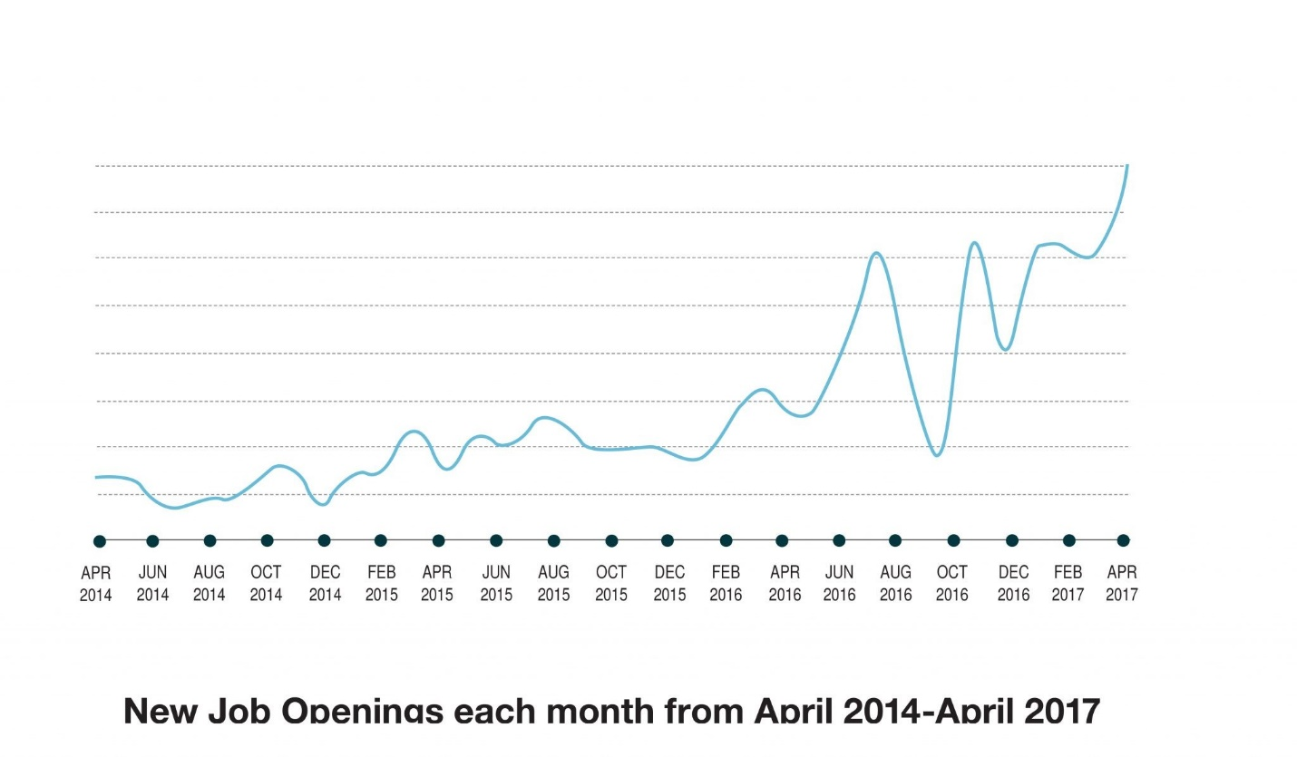

**Increase in trend of Data Science Jobs**